CBS5506 (LC) & CBS5507 (AT) MScGAH CAPSTONE PROJECT/
CBS5508 (LC) & CBS5509 (AT) MScGAH DISSERTATION
for Master of Science in Generative AI and the Humanities

This form should be typewritten in English.

This form is for:
▢ CBS5506 (LC) CAPSTONE PROJECT | ▢ CBS5507 (AT) CAPSTONE PROJECT
▢ CBS5508 (LC) DISSERTATION | ▢ CBS5508 (AT) DISSERTATION

Part A: Student Details

Student Name (1) | : YOU Jieshun
Student No. | : 24041917G
Contact Phone No. | : (+852) 55139342
Email | : 15015689334@163.com

Student Name (2) | : YANG Chenghe
Student No. | : 24110736G
Contact Phone No. | : (+852) 59576837
Email | : frankite@163.com

Part B: Capstone Project/Dissertation Proposal Details

- Proposed Title: Cognitive Empowerment: AI-Driven Training System for Enhancing Brain Health Across All Ages

- Proposed Supervisor:
Name Signature
- Objectives:
The objective of this proposal is the development of a state-of-the-art cognitive training system that tries to improve the brain health of cognitively impaired groups with personalized, AI-driven exercises. Priority has to be given to cognitive domains that allow collaboration on memorization, attention, executive functions, language, and social skills. By applying state-of-the-art technologies, it will include deep learning like Multimodal Large Language Model (LLMs), augmented reality, and cloud computing, offering intuitive, engaging, and accessible experiences that make sure of cognitive improvement and emotional wellbeing. It shall enable elderly users to personalize, receive feedback,

be socially connected and have fun through gamified experiences in a private and secure manner with cross-platform compatibility.

- Capstone Proposal
Background
Cognitive decline seriously affects the life qualities of aged and disabled people, having taken away their autonomy and alienated them from society. Cognitive disorders are a category of diseases affecting cognitive functions such as thinking, memory, attention, comprehension and judgment, language, including Alzheimer's disease, Parkinson's disease, dementia with Lewy bodies, cerebrovascular cognitive impairment resulting from various factors. The development is irreversible and progressive. Although there are no drugs that can completely cure the disease, if one is diagnosed early and intervention starts early, the decline of cognitive functions can be slowed down, and cognitive training has been proved an effective means to relieve the progress of the disease.

The Census and Statistics Department (2023) provides detailed statistical data on household income and wealth in Hong Kong, which refers that “the proportion of elderly persons aged 65 and over is projected to increase from 20.5% in 2021 to 36.0% in 2046”. It is, therefore, high time that, in the context of the aging population of the Hong Kong and the rising prevalence of neurodegenerative disorders, solutions are not being developed, made accessible or scaled up. The cognitive training systems enabled through continuous improvement of state-of-the-art AI (such as the multimodal large language model-LLM) and interactive technologies show considerable promise in offering improved memory, attention, and executive function, among the other key cognitive abilities.

Problem Formulation
Specific Needs of People with Disability or Elderly: Most cognitive training tools are not personalized for accessibility and are not very inclusive, especially to elderly users or users with disabilities.
Technological Gaps: Most of the existing systems lack modern AI capabilities related to speech recognition, deep learning, and multimodal training, which would substantially improve the outcomes.
Engagement and Usability: Current solutions often lack engaging interfaces, reducing user adherence. To enhance stickiness, we propose adding personalized feedback and sharing. These additions will foster a sense of community, excitement, and progress, thereby improving user adherence and effectiveness.
Scalianbility and Accessibility: Most tools for cognitive training require expensive hardware or even professional guidance; this makes them unreachable by the underprivileged.

Furthermore, there is presently a great deal of reliance clinically on either carers or therapists operating cognitive training independently, or via software-driven digital therapies. While the former requires a lot of manpower and is rather expensive, thus pressuring the caregivers seriously, the latter sometimes looks just like

a standard test, which has little flexibility: patients can only answer some pre-set puzzles, far from the memory training for improving cognitive performance. Current digital therapies also lack the ease, interactivity, and intuitiveness that software applications currently have, which seriously affects adherence, or the behavior a

patient exhibits in following medical advice. For patients with cognitive impairment, continuous training has the effect of alleviating symptoms.

Project Significance
The idea of this project was born with the aim of overcoming these drawbacks by developing a powerful AI-driven cognitive training system. Its great potential lies in its ability to:
Improve the Quality of Life: This will facilitate improvement in cognitive and emotional functioning, thus helping users in living a fuller and independent life.
Bridge Accessibility Gaps: Bridge gaps in accessibility by using mobile and web-based platforms to reach out to a heterogeneous group, including underserved populations.
Lead the Wave of Innovation in Healthcare: Chart the future for AI-driven cognitive health solutions.
Empower Caregivers: Provides actionable insights on a user's cognitive and emotional health to guardians and caregivers of elderly users or those with disabilities.

Innovative Features
Personalized Training Programs: Adaptive difficulty using reinforcement learning based on user performance.
Multimodal Interactions: Utilize text, speech, and augmented reality (AR) for immersive and engaging experiences.
Cloud-Edge Hybrid Architecture: Optimize responsiveness and computational efficiency.

Comprehensive Cognitive Modules: Cover memory, attention, language, visuospatial, social, sensory, and emotional training.
Ethical AI Integration: Incorporate transparency and data privacy measures.
Community Integration: Foster social connections through group activities and collaborative tasks, with innovative additions such as personalized training result feedback and sharing, training battles for friendly competition, and team training to enhance camaraderie and mutual support. These features not only promote social integration but also add layers of engagement and motivation, setting our solution apart from traditional cognitive training platforms.

Ethical Concerns

Data Privacy: The application shall provide for secure encryption of data and shall abide by set regulations such as GDPR and HIPAA in handling sensitive user information.
Accessibility: Design user interfaces considering a wide range of disabilities, such as visual, auditory, and motor.
Biases in AI: Train the AI models on various datasets to avoid any cultural or demographic bias.

Emotional Sensitivity: Handle emotional data with care so as to avoid misinterpretation or adverse impacts on users.

Applicability
The system will benefit:
Elderly Individuals: Mitigate age-related cognitive decline and promote independence.
People with Disabilities: Enhance daily cognitive functioning and social integration.
Healthcare Providers: Offer data-driven insights to inform care strategies.
Caregivers: Provide tools for monitoring and supporting loved ones.

Methodology
Lets talk about the Functions and Attributes. In our cognitive training system, we use a lot of deep learning technologies in backend, such as the newest Large Language Model. Also, we choose the best way to deploy those models to interact with users. For details, the way each cognition training section is deployed, the deep learning models used, and the inference is shown below flowchart Fig1:

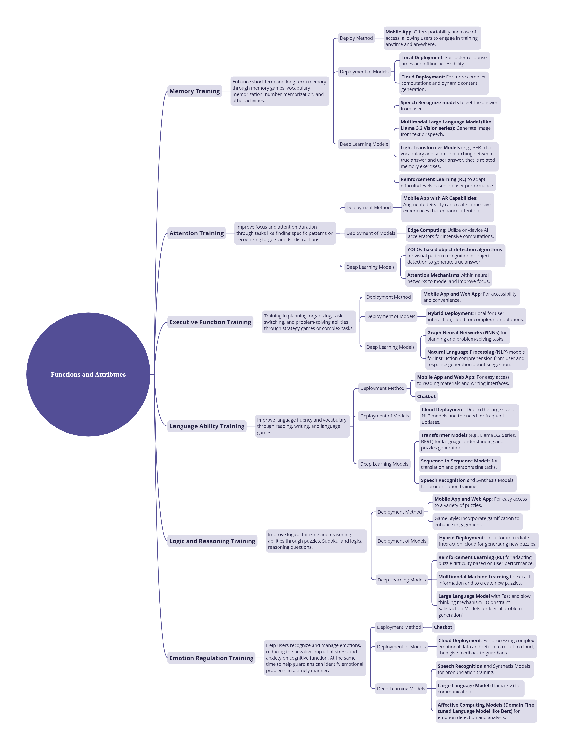
Fig1. Flowchart for the Functions and Attributes

It is important to note that the models used under the “Deep Learning Models” node can be used to include generating material and answers for cognitive training, as well as understanding the information input, information output and decision-making processes that occur when interacting with a user. And for the training or inferencing, we plan to use some cutting edge tricks to improve accuracy, like Mixture of Experts Explained (MoE), Retrieval-augmented generation (RAG) and AI Agent Design.

Based on the design of the functions, we propose some use cases which is shown below:

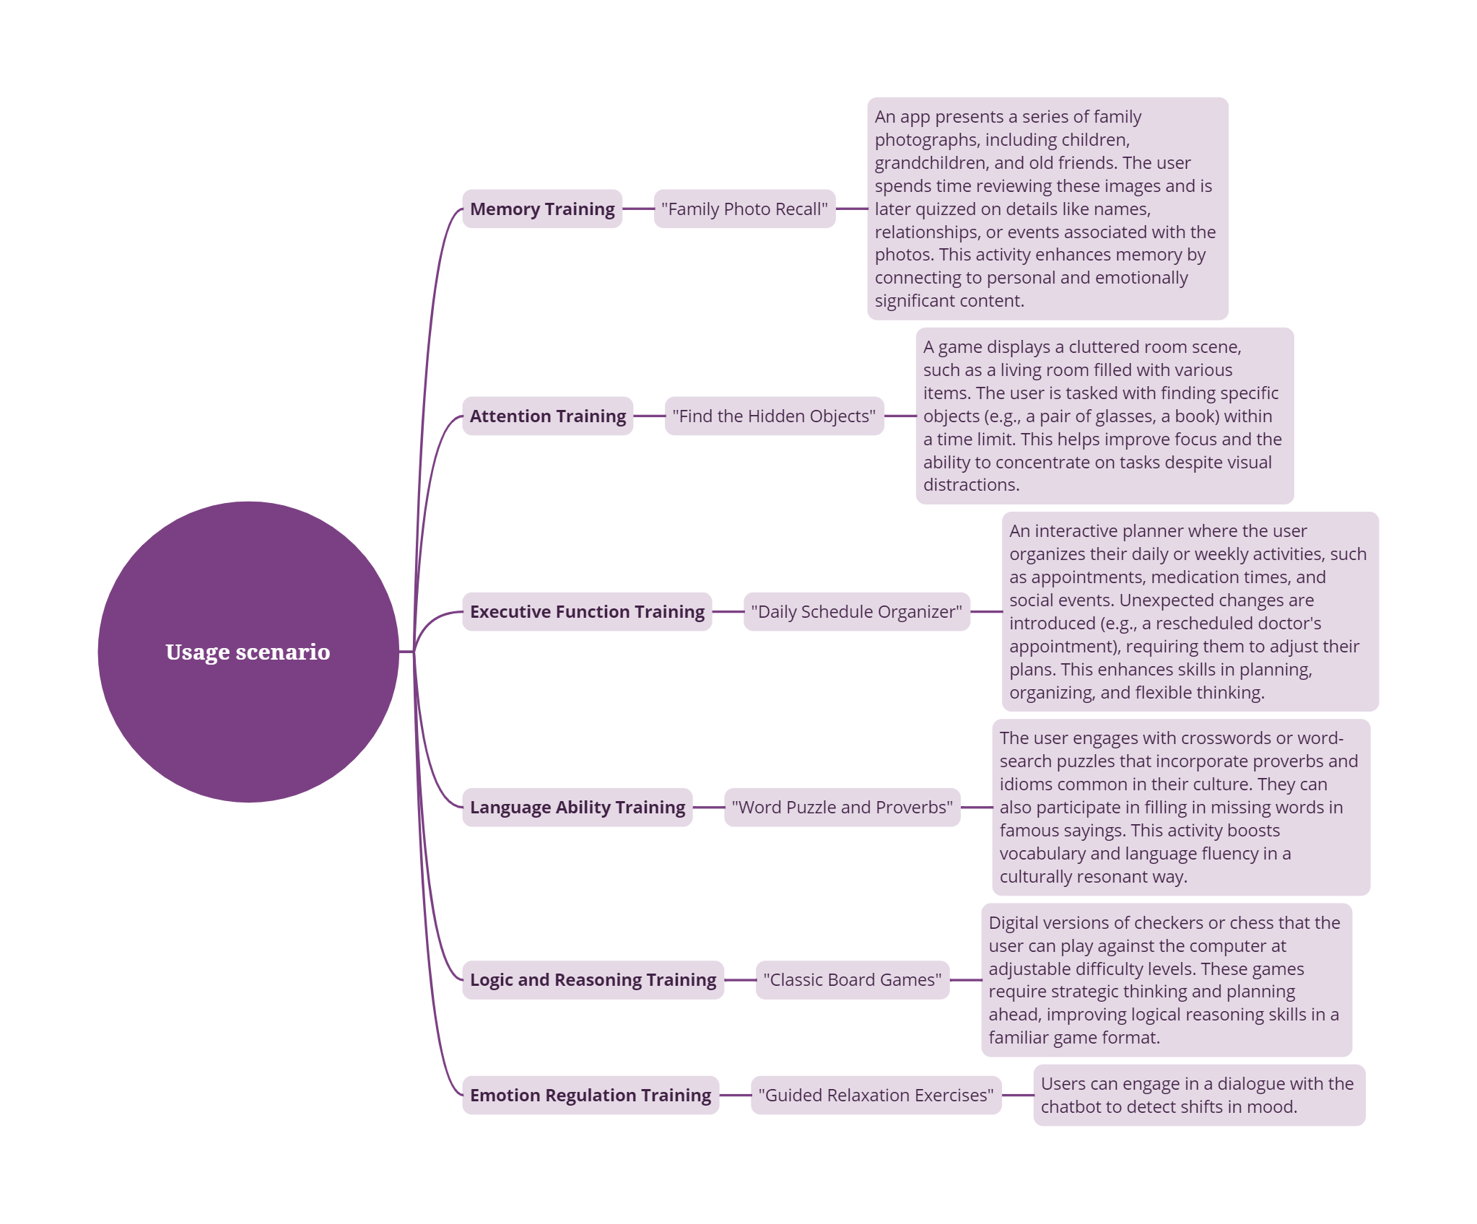
Fig2. Usage Scenarios

Besides, we also propose some product extensions:
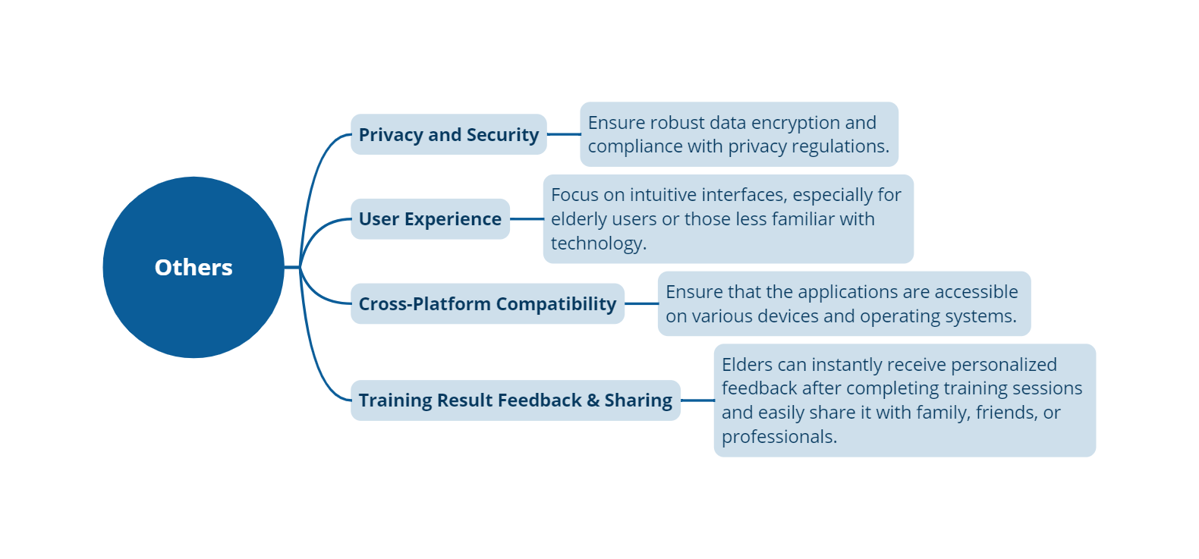
Fig3. Product Extensions

Project Implementation Timeline
Iterative Improvement: Continuously enhance the system based on performance metrics and user input.
Phase | Duration | Key Deliverables
Needs Assessment | 0.5 month | Stakeholder requirements report
System Design | 0.5 months | Detailed system architecture
Model Development | 2 months | Trained AI models and integration prototypes
Platform Development | 2 months | Mobile and web apps with core functionalities
Pilot Testing | 0.5 months | Feedback report and system refinements
Final Deployment | 0.5 months | Full-scale system rollout

Project Budget Allocation Plan

Budget Item | Estimated Cost (HK$) | Description
Cloud and Edge Infrastructure | 32,000 | Rent cloud servers, including GPU instances. Secure data storage solutions and efficient data management services.
Software and Tools Fees | 10,000 | Purchase advanced software licenses and development tools. Subscribe to necessary online services and platforms. Acquire additional or higher-quality datasets for AI model training.
Pilot Testing and Feedback | 8,000 | Conducting pilot tests and gathering insights.

Expected Project Outcome
Improved Cognitive Capabilities: One can witness improved performance on memory, attention, and problem-solving capabilities of the users.
Improved Accessibility: An expandable platform for users across the divide of economic and geographical barriers.
Engaged Communities: Acquisition of social features will be heavily utilized for meaningful interaction and support networks.
Actionable Insights: Avail the value of data to healthcare providers and caregivers.
Innovation Leadership: Setting the benchmark in cognitively driven health solutions with AI.

Major references
[1] Census and Statistics Department. (2023). Hong Kong statistical tables: Household income and wealth statistics. Hong Kong Census and Statistics Department. https://www.censtatd.gov.hk/en/data/stat_report/product/FA100061/att/B72310FA2023XXXXB0100.pdf
[2] 林晓璇, 蓝萍, 车土玲, & 苏裕盛. (2023). 认知训练对阿尔茨海默病的作用机制及其影响研究. Hans Journal of Biomedicine, 13, 151.
[3] Vaswani, A. (2017). Attention is all you need. Advances in Neural Information Processing Systems.
[4] Zeng, M., Tan, X., Wang, R., Ju, Z., Qin, T., & Liu, T. Y. (2021). Musicbert: Symbolic music understanding with large-scale pre-training. arXiv preprint arXiv:2106.05630.
[5] Meta. (2024, November 25). Llama 3.2: Revolutionizing edge AI and vision with open, customizable models. https://ai.meta.com/blog/llama-3-2-connect-2024-vision-edge-mobile-devices/
[6] Radford, A., Kim, J. W., Xu, T., Brockman, G., McLeavey, C., & Sutskever, I. (2023, July). Robust speech recognition via large-scale weak supervision. In International conference on machine learning (pp. 28492-28518). PMLR.
[7] Liu, R., Zhong, Q., Cui, M., Mai, H., Zhang, Q., Xu, S., ... & Du, Y. (2023). The short text matching model enhanced with knowledge via contrastive learning. arXiv preprint arXiv:2304.03898.
[8] Ho, J., Jain, A., & Abbeel, P. (2020). Denoising diffusion probabilistic models. Advances in neural information processing systems, 33, 6840-6851.

[9] Kaelbling, L. P., Littman, M. L., & Moore, A. W. (1996). Reinforcement learning: A survey. Journal of artificial intelligence research, 4, 237-285.
[10] Terven, J., Córdova-Esparza, D. M., & Romero-González, J. A. (2023). A comprehensive review of yolo architectures in computer vision: From yolov1 to yolov8 and yolo-nas. Machine Learning and Knowledge Extraction, 5(4), 1680-1716.

Signature(s) of Student(s):
Date:

FOR OFFICE USE

(Please tick the appropriate box)
□ Proposal is accepted.
Suggested supervisor: _________________________________
□ Proposal is accepted after minor revisions.
Suggested supervisor: _________________________________
□ Proposal is not accepted.
Deadline of proposal re-submission: ________________________

Signature: Date:
Programme Leader

